Case 14-AM,C-Costa Rica-Nicoya-Seated Figure-Whistle-Terra cotta-Pigments-800–1200 CE

Greater Nicoya female AD 800–1200. Linea Vieja area, Costa Rica. Pottery, clay slip, paint. 2.5" tall. an elaborately-painted, burnished and carefully hand-modeled seated nude ceramic figure, posed with arms akimbo, hands resting on the torso and legs extended. She appears to be in a trance state with her eyes closed. Her body is painted to represent complex brown-on-cream linear, geometric and concentric tattoos. There are five vent-holes; two at the nose, two at the femurs and one at the base of the neck. Two suspension holes would serve to make this an amulet.

**Nicoya**, a city on the [Nicoya Peninsula](https://en.wikipedia.org/wiki/Nicoya_Peninsula) of the [Guanacaste province](https://en.wikipedia.org/wiki/Guanacaste_province), [Costa Rica](https://en.wikipedia.org/wiki/Costa_Rica),

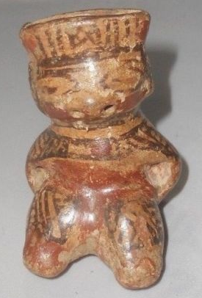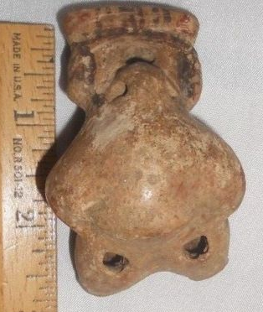

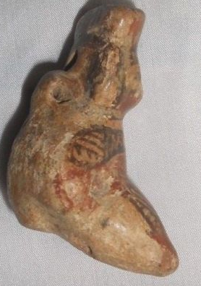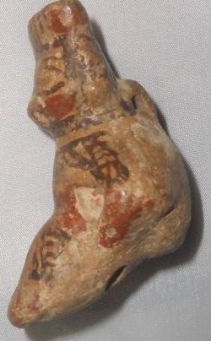

The eminent Costa Rican historian [Carlos Meléndez](https://en.wikipedia.org/wiki/Carlos_Meléndez_Chaverri) took note of the unusual location of the *templo colonial* in the urban core of the city and, based on Oviedo's brief description of the indigenous community, hypothesized that the church had been built atop the indigenous sacrificial mound. Meléndez's hypothesis fits the known Spanish pattern of direct superimposition of Catholic politico-religious structures on indigenous structures such as [pyramids](https://en.wikipedia.org/wiki/Pyramids) in Mesoamerica and Andean South America, or [kiva](https://en.wikipedia.org/wiki/Kiva) structures in the U.S. Southwest. In short, Meléndez argued that the location of the colonial church is not merely an aberration from the common Iberian pattern of facing the plaza but is coincident with the location of the sacrificial mound in the northeastern corner of the plaza of indigenous Nicoya as described by Oviedo in 1529.[[8]](https://en.wikipedia.org/wiki/Nicoya" \l "cite_note-8)

Archaeological excavations were conducted in and around the city of Nicoya in the early 1990s to test these theories and to better understand how the indigenous community was transformed into a colonial town.[[9]](https://en.wikipedia.org/wiki/Nicoya" \l "cite_note-9) Excavations in the center of Nicoya failed to produce any evidence of a substantial pre-Columbian presence in the city's center. Investigations into the surrounding valley failed to identify unequivocally a single site as the probable home to Nicoya. However, several large (5–10 hectare/12–24 acre) archaeological sites were in similar ecological niches throughout the valley. They are situated along river and stream banks at the point where streams leave the hills that surround the valley and cross the undulating valley floor.

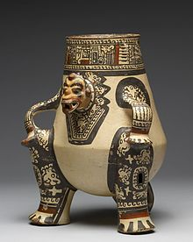

This [Pataky](https://en.wikipedia.org/wiki/Pataky) ceramic (late Period VI, AD 1000-1350) portrays a seated [shaman](https://en.wikipedia.org/wiki/Shaman) transformed into a [jaguar spirit](https://en.wikipedia.org/wiki/Jaguars_in_Mesoamerican_cultures) companion form.

At least two of these sites are considered likely candidates for protohistoric Nicoya. One is just outside contemporary Nicoya along the banks of the [Rio Chipanzé](https://en.wikipedia.org/w/index.php?title=Rio_Chipanzé&action=edit&redlink=1). The other is in the hamlet of [Sabana Grande](https://en.wikipedia.org/w/index.php?title=Sabana_Grande,_Costa_Rica&action=edit&redlink=1), six kilometers north of Nicoya. This site appears to be larger than the rest; it exhibits low [earthen mounds](https://en.wikipedia.org/wiki/Mound) and is particularly prized by local looters for its high-quality [polychrome](https://en.wikipedia.org/wiki/Polychrome) pottery and gold artifacts. Apparently a much greater quantity of high-quality artifacts have been removed from the vicinity of Sabana Grande than from Nicoya or anywhere else in the valley. Furthermore, it is interesting to note that the colonial [*ejido*](https://en.wikipedia.org/wiki/Ejido) (lands held in common by the indigenous community) of the Indian community of Nicoya was in Sabana Grande, not Nicoya.[[10]](https://en.wikipedia.org/wiki/Nicoya" \l "cite_note-10)

It is only possible to consider either of these sites as protohistoic Nicoya if we discard the notion that it was a single community of over more than 6,000. Neither site is near the size necessary to hold that number of people if we accept even as an approximate Newson's (1987:87) estimates of 0.045 to 0.06 persons/hectare for Pacific Nicaragua at Spanish contact, and as little as 0.02 persons/hectare for Nicoya. A closer reading of the ethnohistoric material in conjunction with the archaeological information is necessary to form a more realistic picture of Nicoya on the eve of conquest. It is worthwhile returning to Andrés de Cereceda, treasurer of Gil Gonzalez Dávila's 1522 expedition, and review his own words in regard to Nicoya:

"The chief Nicoya is five leagues further on, inland: they baptized 6,603 souls; he gave 13,442 pesos in gold, with a little more that the chief Mateo gave".[[11]](https://en.wikipedia.org/wiki/Nicoya" \l "cite_note-11)

Cereceda's figure of 6,603 is typically taken to represent the number of inhabitants of the *cacique*, Nicoya's town, but Cereceda never makes that assertion, only that the expedition baptized that number of people. Furthermore, he refers to a second chief, Mateo, whose residence was never specified.

An alternative interpretation of Cereceda's figures would understand them as representing the inhabitants of several settlements politically affiliated with Nicoya but not the members of one massive community. The *cacique* Nicoya may not have had tributary villages under his direct control. But it is not unlikely that there were several villages within his orbit of influence that he could persuade to treat with the Spanish. A model of dispersed settlement of politically affiliated villages rather than one large nucleated town better fits the archaeological and ethnohistoric information. Oviedo, who visited Nicoya in 1529 and recorded aspects of the town's layout, never remarked on the great size of the settlement. Oviedo was in Nicoya before precipitous population decline had taken its effect, and one would expect some remark from this astute observer had Nicoya been such a populous and highly nucleated center.

If the above hypothesis is true, what does modern-day Nicoya represent historically? Among other tools of colonial administration, the Spanish crown created a policy called *congregación*, or the forced resettlement of native peoples into nucleated settlements to more closely watch and control their charges. The evidence leads one to further hypothesize that the present-day Nicoya is the product of Spanish colonial *congregación*, formed by the forced amalgamation of people from the pre-Hispanic settlements dispersed throughout the region. When this may have been done, and under what circumstances, are unknown. As mentioned above, the historical documents, which would have recorded such an event, would have been lost in the 1783 fire that completely destroyed the colonial archives in Nicoya. Further research in other repositories may yet provide confirmation for this interpretation.